**DAILY ONLINE ACTIVITIES SUMMARY**

|  |  |  |  |
| --- | --- | --- | --- |
| **Date:** | 16/07/2020 | **Name:** | Krishnitha |
| **Sem & Sec** | 4th sem, A Section | **USN:** | 4AL18CS039 |
| **Online Test Summary** | | | |
| **Subject** | NA | | |
| **Max. Marks** | NA | **Score** | NA |
| **Certification Course Summary** | | | |
| **Course** | Data Scientist | | |
| **Certificate Provider** | AWS | **Duration:** | 3 hrs |
| **Coding Challenges** | | | |
| **Problem Statement:**  Write the C program to find the next greater element. | | | |
| **Status:** Executed | | | |
| **Uploaded the report in GitHub** | | YES | |
| **If yes Repository name** | | <https://github.com/krishnitha/C-coding> | |
| **Uploaded the report in slack** | | YES | |

**Certification Course Details:**

Today I started the new course “Data Scientist” by AWS. Today I learnt about big data analysis and architecture, visualization and streaming. I also completed the assignments of these two modules.



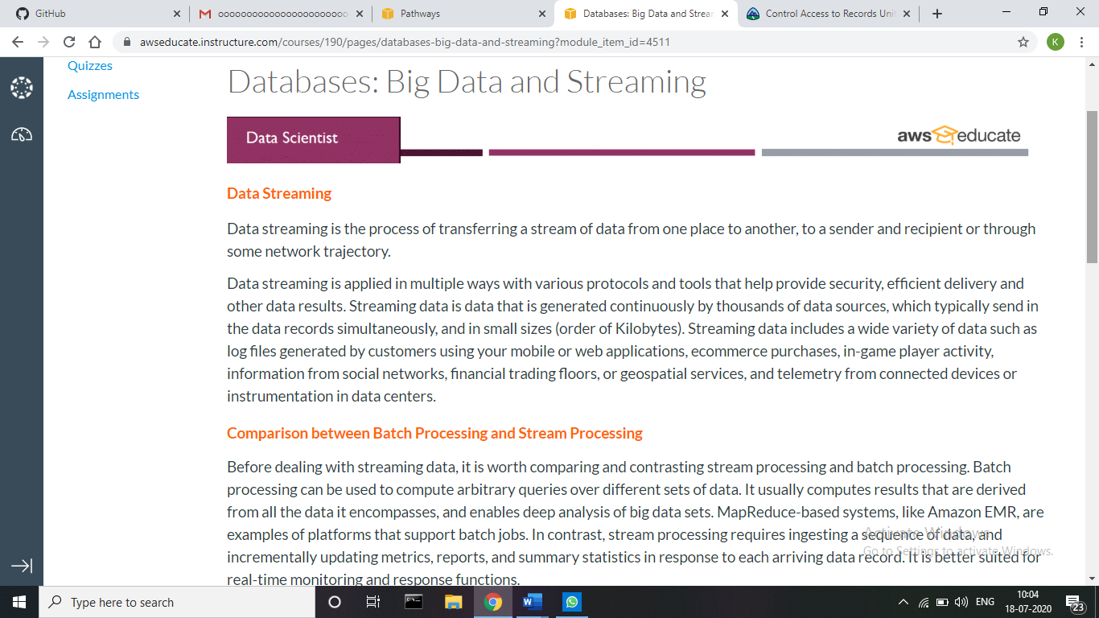

**Webinar Details:**

Today we had a webinar on “Programming in C” by Assistant Professor Ms. Megha D. hedge, CSE department- AIET.

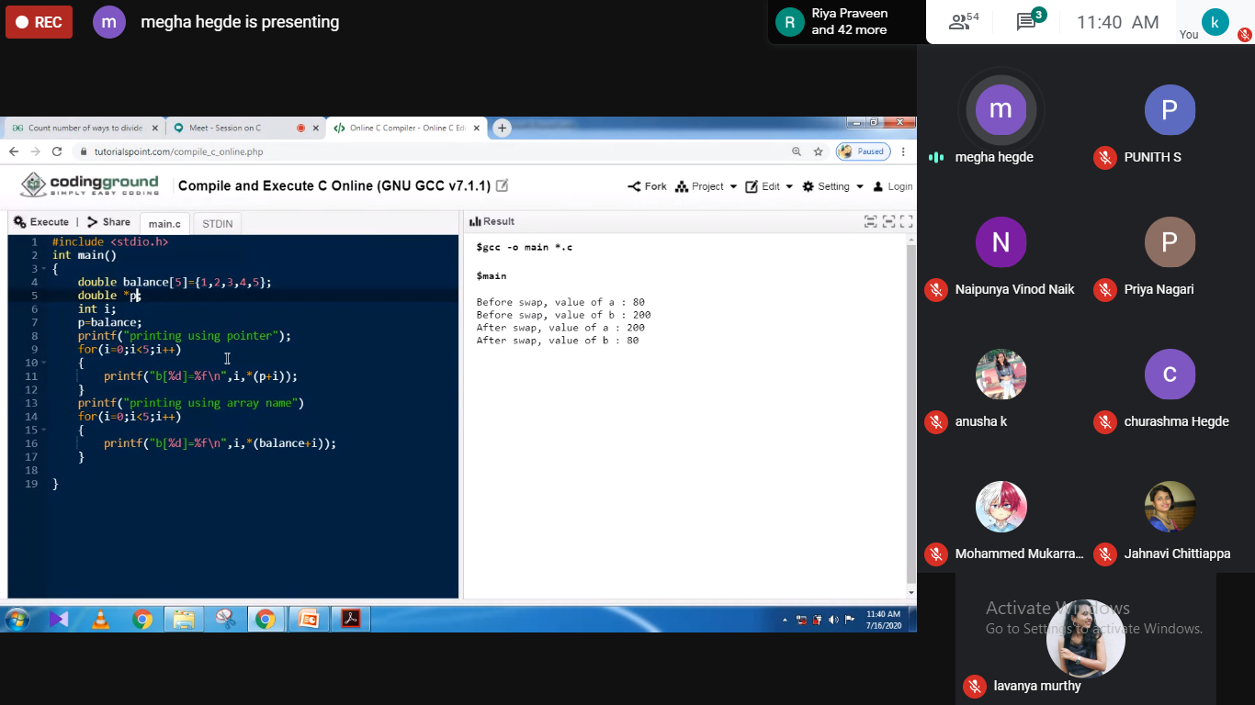

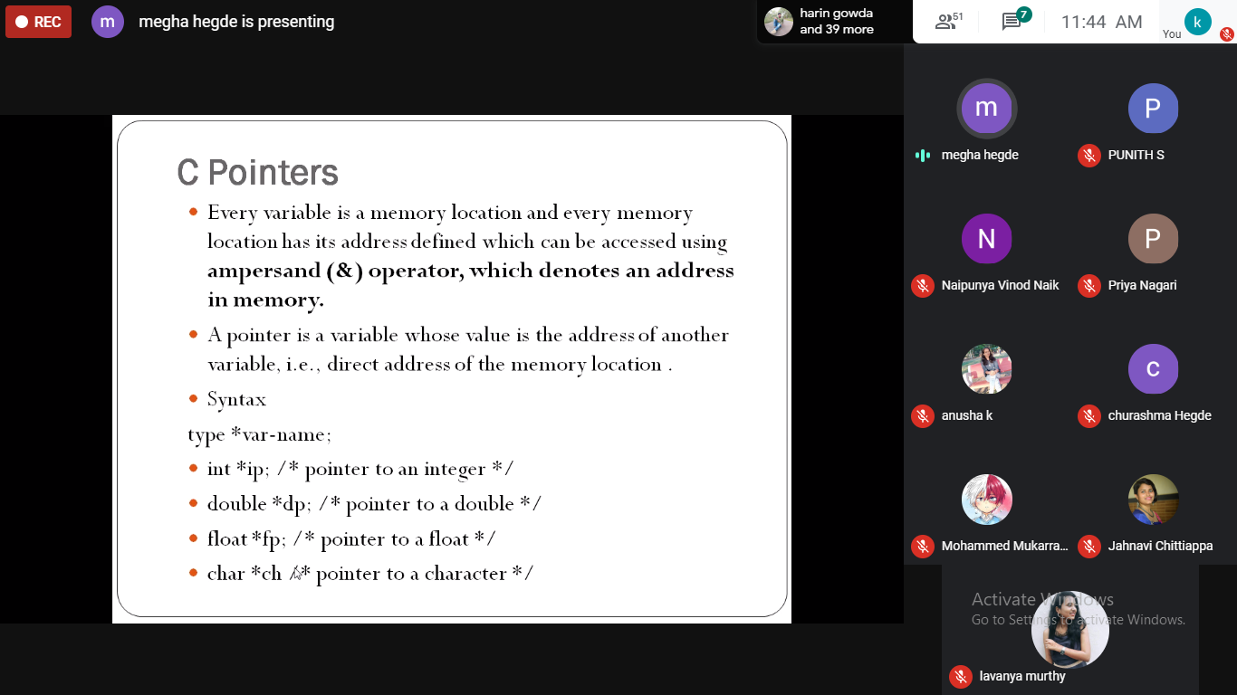

**Coding Challenges Details:**

**Problem:** Write the C program to find the next greater element.

Given an array, print the Next Greater Element (NGE) for every element. The Next greater Element for an element x is the first greater element on the right side of x in array. Elements for which no greater element exist, consider next greater element as -1.

**Examples:**

For any array, rightmost element always has next greater element as -1.

For an array which is sorted in decreasing order, all elements have next greater element as -1.

For the input array [4, 5, 2, 25}, the next greater elements for each element are as follows.

Element NGE

4 🡪 5

5 🡪 25

2 🡪 25

25 🡪 -1

d) For the input array [13, 7, 6, 12}, the next greater elements for each element are as follows.

Element NGE

13 🡪 -1

7 🡪 12

6 🡪 12

12 🡪 -1

**Solution:** Uploaded it in GitHub

